July 2023

- Lurasidone mechanism of action. Options D2 5HT2a 5HT7 antagonist, D2 antagonist 5HT2a 5HT7 agonist
- Least sexual side effects : vortioxetine
- Topiramate prominent side effect: weight loss
- Lithium prominent side effect: worsening psoriasis
- Clozapine most affinity to 5HT2A receptor
- Lamotrigine mechanism of action
- NMDA most affinity to which receptor
- Methamphetamine most affinity to dopamine vesicles/serotonin vesicles
- MDMA most affinity to dopamine vesicles/serotonin vesicles
- Molecular Mechanism of NMDA receptor
- Molecular Mechanism of SERT transporter
- Types of autoimmune encephalitis. 3 EMIs about which antibodies/antigens are implicated in these: one with limbic hyperactivity hyponatremia and few psychiatric symptoms. Options: NMDA/ AQP4/ GABA-A/ GABA-B/ more?
- 2nd flu like prodrome and seizures: Options: NMDA/ AQP4/ GABA-A/ GABA-B/ more?
- 3rd optic nerve and spine inflammation: Options: NMDA/ AQP4/ GABA-A/ GABA-B/ more?
- Relatively preserved in schizophrenia: short term/long term/procedural/semantic
- Test for short term memory
- Test for abstraction , cognitive estimates and proverb testing both in options
- EMI for abstraction
- Cocktail party phenomenon options had Selective auditory attention/ involuntary attention
- Test for selective attention . Stroop
- What means ‘meaning of words’ in linguistics. Options were lexical semantics, phonology, orthography, syntax
- Pathophysiologic mechanism of korsakoffs. Mamillary body alphaketoglutarate dysfunction
- Pathophysiologic mechanism of Multisystem atrophy
- Which gene codes for P-glycoprotein
- Which gene codes for alpha synuclein
- Which molecule is compnent of BBB
- A womans daughter is undergoing chemotherapy since 3 months. Woman has discussed this with friends and family. It reminds her of her mothers death from cancer. Options were acute stress/ adjustment/ complex PTSD/ PTSD
- How many episodes of depression needed for a diagnosis of recurrent depressive disorder
- Consolidation of emotional memories in which stage of sleep
- A man is told he needs to get foot amputation, he is admitted and sees a patient who has had a similar surgery. He breaks equipment and says death is better than this. Acute stress reaction/ adjustment disorder
- Difference in Avoidant Restrictive Food Intake and Anorexia. Options were intentional weight loss, significant functional impairment
- Difference between Hoarding Disorder and OCD. Options were objects have intrinsic value/ absence of obsessional thoughts
- How long after loss event can we diagnose prolonged grief disorder: 1 month/6 months/1 year
- Qualifiers for depressive episode in ICD-11 . Options were biological symptoms/pseudodementia/melancholic
- Child appears shocked and does not come close when offered help. Answer was reactive attachment disorder.
- What feature is seen in reactive attachment disorder. Options cognitive deficit/ language deficit/hyperactivity/ fearfulness
- Child goes to daycare for first time. Shows no reaction when he is left by parents and neither when they come back. Options reactive attachment disorder/ autism spectrum disorder/avoidant attachment/anxious resistant attachment
- Brain organoid represents which age human brain. Options 10years/ 20 years/ 6 days/ 2nd trimester
- Prazosin best indicated for which disease. ADHD/ anxiety/autism
- Pindolol best indicated for which disorder. ADHD/ anxiety/ autism/ depression
- Guanfacine best indicated for which disorder . ADHD/ autism/ anxiety
- Propanolol best indicated for which disorder. ADHD/ autism/ anxiety
- Greatest improvement of cognitive symptoms in schizophrenia with which neurotransmitter Ach/dopamine/NE/serotonin
- Abused by exam taking students atomoxetine/guanfacine
- Empathy is influenced by DLPFC/insula
- Given in REM sleep behavior disorder prazosin/trazodone/melatonin
- Loss of orexin producing neurons in. Narcolepsy
- Atomoxetine MOA
- Nomothetic personality theory.how are dimensions divided. Options were reliability over time/ reliability aming cultures?/ universalizability in assessment/ individual variability
- What is the critique on these dimensions. Options were reliability over time/ reliability aming cultures?/ universalizability in assessment/ individual variability
- What is true about categorical classification of disorders. Options were easy collection of epidemiological data/ allow for accommodation of different levels of severity/?
- Bayes theory. What is an already held belief called options were evidence data/ prior/posterior
- Most common inclusion in FTD. Options were . Tau positive amyloid negative, tau positive amyloid positive, amyloid positive, tau positive ubiquitin negative, tau positive ubiquitin positive
- LRRK2 mutation in? It was an option in a question
- How many times does G protein coupled receptor pass through the cell membrane. Answer 7 times
- Molecular mechanism of glutamate receptor
- Which antipsychotic reaches peak plasma concentration earliest. Options quetiapine/olanzapine/sulpiride/aripiprazole
- Area under curve denotes: options were exposure to drug over time( this seemed correct, don’t remember others)
- In first order kinetics: constant fraction of drug eliminated in unit time/ constant amount eliminated in unit time/ log of plasma concentration plotted against time will show non-linear elimination/ log of plasma concentration plotted against time will show linear elimination
- Absorption constant is independent of: elimination constant/ form of drug/ composition of drug/ extravascular route of administration/ food taken with drug
- Patient sticking to treatment is due to: referent power/legitimate power/information power/expert power
- Campaign about harms of smoking: referent power/legitimate power/information power/expert power
- What is most likely to induce retrospective falsification of memory: warning given before misleading/ person being middle aged/ what is being told aligns with previously held belief
- Incorrect recall is what type of memory issue: cryptamnesia/ primacy effect/ falsification/ pro active falsification/ retro active falsification
- Man is seeing faces as frightening and misshapen. Options paraprosopia/ chromatopsia/ metamorphopsia/ pelopsia/ palinopsia
- Woman sees a cat and then sees her in different situations throughout the day. Illusion/ hallucination/ palinopsia
- Complex PTSD differentiated from PTSD by: correct option was poor interpersonal relationships
- Ebstein anomaly is caused by : Lithium/Valproate
- Hypolasia of which structure in Autism: correct option was cerebellar vermis
- What is true about Purines: found only in eukaryotes/include cytosine and thymine, can only be obtained from diet, are uncommon nitrogen containing compounds
- What is the most biologically plausible genetic basis of schizophrenia options DISC1 and NRG1
- Kaiser CDC ACE study. What is true: parental divorce was included as an ACE, linear relationship between number of abuse categories and depression, psychological abuse was not inlcuded in original study
- Metabolic syndrome in present in what percentage of patients in CATIE trial. Options 41-50, 31-40
- Research replicated finding about altruism: altruism is present at birth, altruism is an exclusively human behavior, altruism causes reduced physical perception of pain, altruism doesnt improve well being/ empathy increases altruism for ethnic outgroups?
- Increased maternal sensitivity during attachment behaviour is due to increased functional connectivity of: hippocampus and putamen, hippocampus and amygdala, hippocampus and limbic system
- Epigenetic mechanism by maternal attachment affects which neurotransmitter: oxytocin, serotonin, dopamine
- Hallucinogenic effects of psychedelics are produced by 5HT1, 5HT2, 5HT3
- Motor speed assessed by which test: Trail making/ finger tap test
- Non dominant side lesion causes : constructional apraxia(Gestalt) constructional apraxia(detail)
- Gestalt principle shown in this figure: 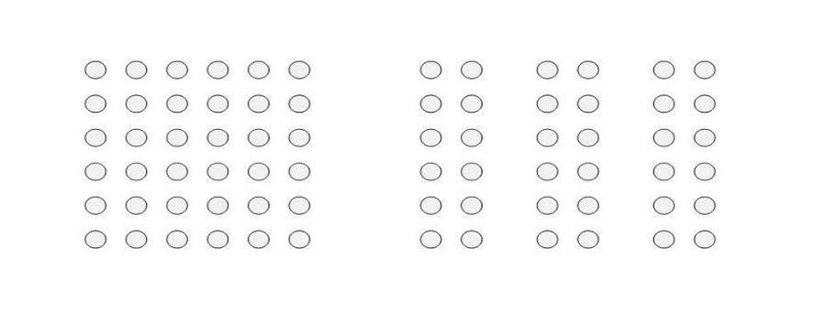proximity/good figure/closure
- Narrowest therapeutic index: doxepin/ clomethizol
- Piaget theory. Most important feature of sensorimotor stage: egocentrism/ conservation/ object permanence
- Most biologically important metabolite: diazepam, oxazepam, lorazepam
- When a person wants to fit in socially and be perceived as a ‘nice person’ he is exhibiting which level of morality: social order/ concventional, self interest
- Default mode network involves: parietal lobe/temporal lobe
- Interviewer rated scale: HADS/ HAMD/ PHQ
- Advantage of using cross sectional method in a study with children: reduced attrition/ easily accessible data
- Test of premorbid intelligence: NART
- Which is true about alcohol dependence in young people: incidence of binge drinking is lower in 18–20-year-olds, early onset of drinking is a predictor of later dependence
- In vivo measurement of neurotransmitters by which technique: PET, fMRI, MRE, MRS
- FDG is used in which technique: PET/fMRI
- Ion channel most implicated in schizophrenia: calcium/ potassium/ chloride/ sodium
- The concept that people’s interaction are influenced by each other which in turn are influenced by others - Circular causality/ triangulation/ detouring/enmeshment
- When family members gang up on other family members: Circular causality/ triangulation/ detouring/enmeshment
- Rate limiting step in Alcohol metabolism: alcohol dehydrogenase/ aldehyde dehydrogenase
- EPS produced at what percentage D2 occupancy: 0.6, 0.8, 0.2
- Recombination fraction value the means that two genes will be independently assorted : 0.2, 0.1, 0.5, 1
- Metabotropic receptors are : G protein coupled
- 1st line treatment in clozapine induced constipation: methylcellulose, senna, lactulose
- DBS in OCD targets: anterior limb of internal capsule
- Dentate gyrus is a part of: hippocampus
- Which requires longest duration for diagnosis: schizoaffective/ adjustment/ schizophrenia/delusional disorder/ schizotypal disorder
- Muscarinic receptors are mainly found in : parasympathetic ganglia, sympathetic ganglia/ peripheral postsynaptic receptors/ neuromuscular junctions
- Aggression is reduced by: observing the aggressor receive punishment, appeasement doesnt have any effect, no aggressive responses to the aggressor
- What is true about pre linguistic communication: extended in autistic children, lost over later life, other options too
- What is true about adolescent turmoil: self deprecation and worthlessness is common, difficulties with parents are common, adolescents with reduced parental contact and social support are underrepresented in group with psychiatric diagnosis, most will undergo peer group turmoil
- Bereavement in children: young children more affected than older, boys more affected than girls, reduced cortisol response in later life, resolved in 3 months, school going children revert to magical thinking, regression occurs within 3 months.
- At what stage in Conrad’s model does the individual start to find new meaning for psychological processes: Trema, apophany, anastrophy, residuum
- Fluent plausible lying with fantastical elements: confabulation/ falsification/ pseudologia fantastica
- Southern blot used for: DNA/ protein/ RNA/ DNA binding protein
- Gregory (1970) theory about perception? Correct was perception depends on making inferences on past experiences
- Naloxone is mixed with buprenorphine because: reduces chances of misuse (by deterring patients from injecting it as it will cause severe withdrawal if injected)
- Many bystanders but no one is likely to help. Options: bystander effect
- Policeman comes to scene of crime, sees a well dressed man and decides he cannot be the culprit. Halo effect/ barnum effect/ pygmalion effect
- Which is first rank symptom: man sees clock strike 12 and believes he is Messiah/ voices commanding him/ believing his neighbors are poisoning him
- Last part of brain to be myelinated: anterior frontal pole/ caudate/ amygdala
- New information affecting old memories: proactive falsification/ ganser/ retroactive falsification/falsification/ paramnesia/cryptamnesia
- Sherif’s experiments on group were for: options about objectives?
- Caffeine effect is DIRECTLY reversed by: sigma receptors/ adenosine receptors
- Healthcare workers wash hand more when they are being observed, what explains this: Hawthorne effect
- Locus coeruleus is involved in which pathways: serotonergic, ACh, noradrenergic
- Intellectual disability diagnosis requires IQ to be how many standard deviations away from mean: 2/3/4/5
- Difference between hypomania and mania: decreased sleep need/ flight of ideas/ psychotic symptoms
- What is the sequence of 3 stges of separation anxiety: protest detachment despair / protest despair detachment
- 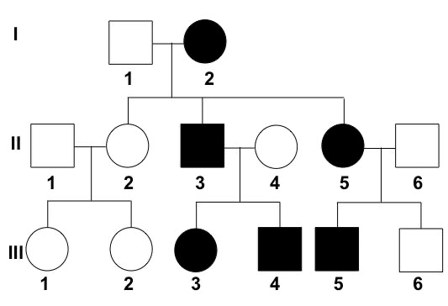Which pattern of inheritance shown in this pedigree: autosomal dominant/ autosomal recessive/ x-linked dominant/X-linked recessive
- In Freud’s theory, not resolving a stage results in: fixations/?
- Mild personality disorder in ICD-11 is equivalent to what in DSM-V: some impairment / no impairment/ severe impairment
- Woman says she sees colors when she hears husband’s voice or laughter, this is: synaesthesia
- Sample of speech: this is a hospital, hospital is where doctors are trained, doctors are ? Apple keeps doctor away, newton saw apple, newton discovered gravity. What is this: loosening of associations / flight of ideas.
- Parenting with rules but no rigidity and responsiveness present: authoriative
- Child that follows ruled but has poor self esteem, what type of parenting: authoritarian
- Superstition theory of OCD states that: compulsions formed due to immediate relief from anxiety/ behaviour and stimulus are paired by chance/ mental processes by which threatening thoughts are removed
- What differentiates oppositional defiant disorder from intermittent explosive disorder: physical aggression / outburst out of proportion to stimulus
- Inflammatory marker common in depression: IL-4/ IL-6/ IL-11/ IL-13
- Which of the following is not seen in serotonin syndrome: nausea/ headache/ tremors/ diplopia
- Adding new information to existing information and expanding it is: adaptation/ assimilation/ accomodation
- Internal Structure of knowledge that humans have to understand a concept is: schema/archetype
- Which of the following medications work by acetylcholine esterase inhibition: galantamine/ memantine
- What is the mechanism of Memantine’s actine: NMDA antagonism/ uncompetitive NMDA anatagonsm
- Phagocytic cells in the nervous system: astrocytes/ microglia/ macrophages
- Which cells secrete glutamate: pyramidal/ Schwann/ astrocyte/ stellate
- GABA is projected onto which cell type in the striatum: pyramidal / medium spiny neurons
- Which cells responsible for myelination in the CNS: oligodendrocyte/ schwann
- Which if the following is seen in pregnancy: increased GFR/ increased binding if drugs to albumin/ decreased volume of distribution of water soluble drugs
- Lyonization is seen in: Down/ klinefilter
- Test for executive function: clock drawing/ digit span/ stroop/ wisconsin card sorting
- Test for set shifting: stroop/ clock drawing/ wisconsin card sort
- Reciprocal inhibition is employed in: systematic desensitization
- What is true about Stupor: patient appears awake and alert/ it exists on a spectrum of wakefulness to coma/ consciousness is decreased

